Boat America: Presented by The U.S. Coast Guard Auxiliary
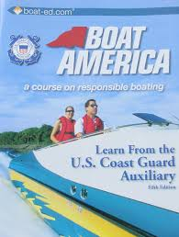

This basic boating class will give you the knowledge needed to obtain a (State Name) Boating Safety Education Card, which is required by anyone born after (Date). Some boating insurance companies will offer discounts on boating insurance to boaters successfully completing this course.

Boat America.
The United States Coast Guard Auxiliary presents this course.
Location:
Classroom:
Dates:
Times:
There is no charge for these classes.

The class is open to the first (state number to enroll) students who submit a request to participate.

To enroll, contact: (Your contact information)

Boat America is a class that offers in-depth and interesting content. It provides the knowledge required to obtain a boating certificate.

TOPICS INCLUDE
- Introduction to Boating – Types of power boats, boating vocabulary, sailboats, paddle boats, powering boats, and engine types.
- Boating Law – Boat registration, regulations, hull identification numbers, required safety equipment, Federal and state boating laws, and reporting accidents.
- Safety Equipment – Life jackets, fire extinguishers, sound-producing devices, visual distress signals, anchors, and other safety equipment.
- Safe Operation and Navigation – Buoys and beacons, aids to navigation, navigation rules, docking, and the dangers of alcohol on the water.
- Boating Emergencies – Hypothermia, boating accidents, man overboard, capsizing, emergency radio calls, carbon monoxide dangers, and weather.
- Trailering – Types of trailers, lights, hitches, and towing a trailer.
- Sports and Boating – Water-skiing, hunting and hunting gear, Personal Watercraft, and other boating tips.

